Name________________________________ Date_________________
Geometry
Circles and External Segments
Exploration 1:
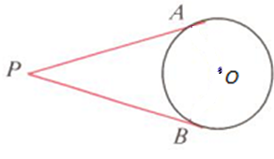

Exploration 2:
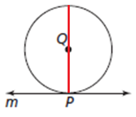

Example 1:
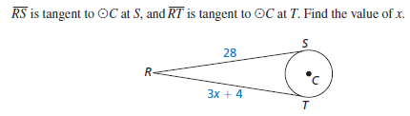

Example 2:

Example 3:

Example 4:
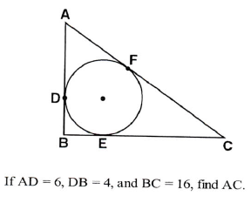

Two Secants Theorem
If two secant segments are drawn to a circle from the same external point, the product of the length of one secant segment and its external part is equal to the product of the length of the other secant segment and its external part.

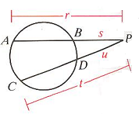
Write an expression:

Secant and Tangent Theorem
If a secant segment and tangent segment are drawn to a circle from the same external point, the product of the length of the secant segment and its external part equals the square of the length of the tangent segment.

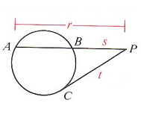
Write an expression:

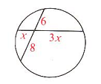  1) Find the value of x. | 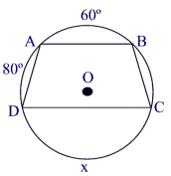  2)Given: Circle O,  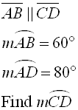
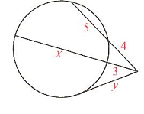  3) Find the values of x and y. | 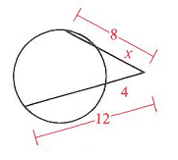  4) Find the value of x.
5) Given: Circle with indicated center,  marked parallels. Find x.  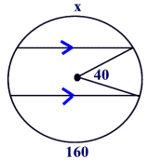 | 6) Given: Circle O, CD = 16, AB = 16  OB = 10. Find OF.  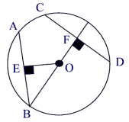
7) Given: circle with two chords as marked. Find x.  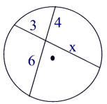 | 8) In the accompanying diagram, and are tangent to the indicated circle. From his pasture gate, a horse sees the barn and the farm pond. The angle formed between his line of sight of the barn and his line of sight of the pond is 30 degrees. How many degrees are in angle HAY?  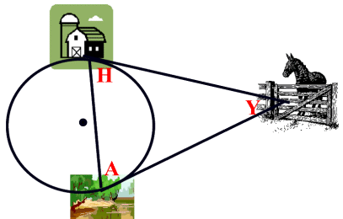
9) Given: circle with tangent, secant and chord. Find x.  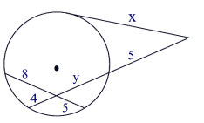 | 10) Given: circle with two secants. Find x.  